Mid-Point Check-in

Project 2048 Game

CS240

Ting Gao, Cancan Huang, Jialei Lyu, Jacqueline Tan, Yushi Yao (alphabetically order of last name)

What progress have you made?

We have written most of the GUI including grid, tiles, buttons, built the framework of grid class, keyboard input detection, and spawning a “2” tile at random empty position. The size of grid can be changed by pressing the “restart” button and inputting a different size.

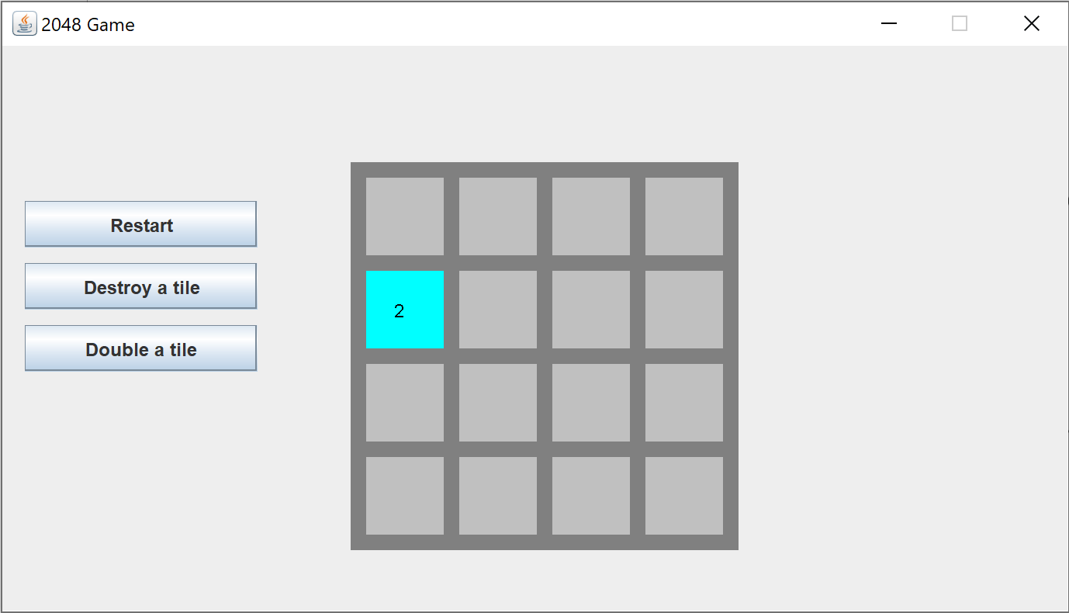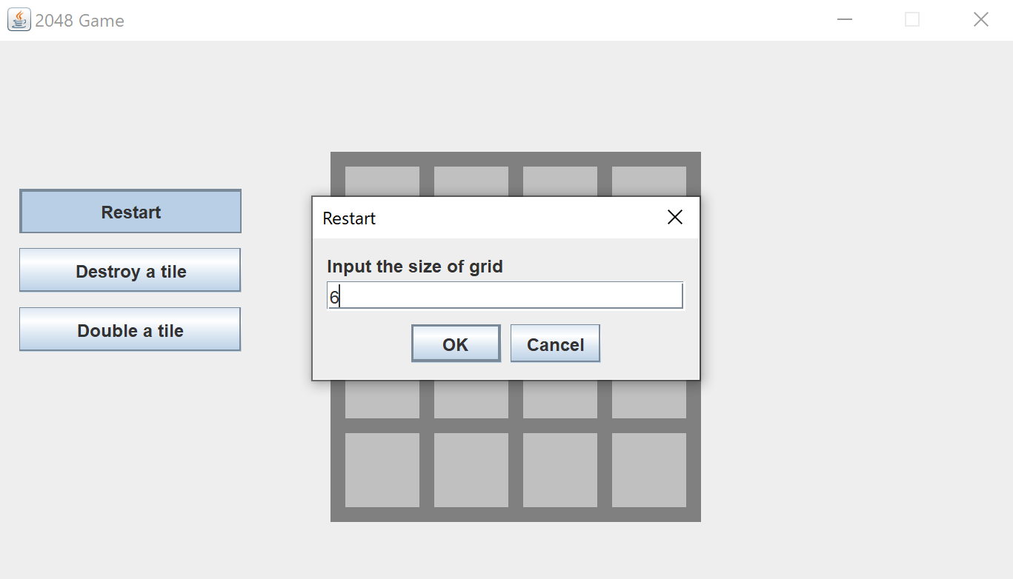

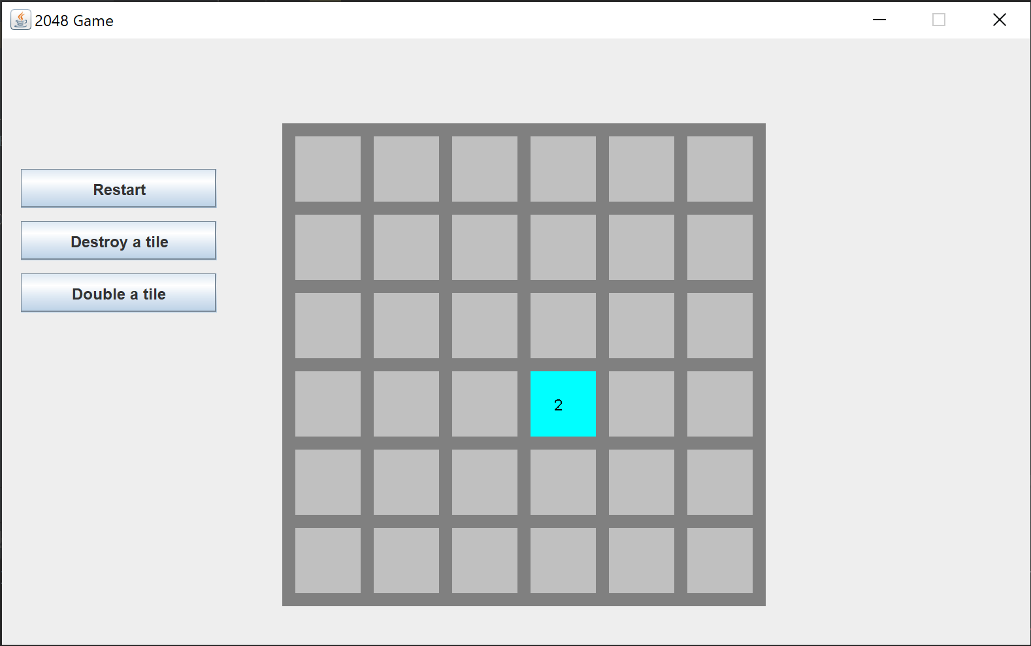

What do you still have left to do?

Description – Feb/19

Move and merge logic – Feb/20

Game over detection – Feb/21

Score – Feb/22

How have you implemented/utilized concepts from this course?­

We use algorithm calculation to look for efficient calculation of move/merge/game-over.

Give two example of design decisions you have made and why you made those specific decisions

We use two-dimensional array to represent the grid of 2048 game instead of other data structures we learned in this course because we believe two-dimensional array is the most similar one to a n \* n grid and 2048 game require mass data modification.

Tile of higher value is drawn in deeper color, making the game visually intuitive.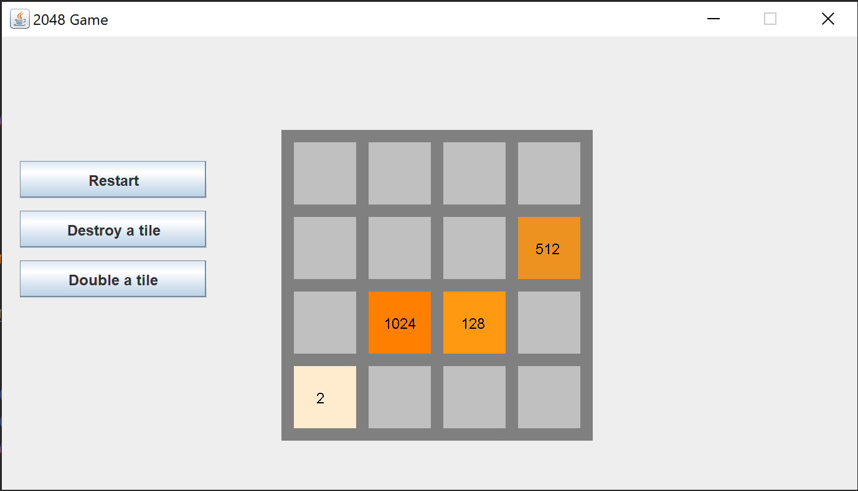

Have you started testing your project? If so, how?

Each time we made a modification, we would write test code to search for bugs, dash out methods not written yet, and add breakpoint or System.out.println to make sure code is working properly. For example, when we haven’t finished spawn method to spawn “2” in random empty position, we added “2” manually to test other code/method.